Software Requirements Specification

Online Examination System

Team:
Prateek Gupta
Jatin Chauhan

Submitted To:

Minor Project Lab

<<Any comments inside double brackets such as these are not part of this SRS but are comments upon this SRS example to help the User understand the point being made.

Refer to the SRS Template for details on the purpose and rules for each section of this document.

This work is based upon Online Examination System as of Semester Project, 2019.>>

Table of Contents

Table of Contents i
1.0. Introduction 1
1.1. Purpose 1
1.2. Scope of Project 1
1.3. Overview of Document 2
2.0. Overall Description 4
2.1 System Environment 4
2.2 Functional Requirements Specification 5
2.3 User Characteristics 15
2.4 Non-Functional Requirements 15
2.5 Characteristic Of The Proposed System 16 3.0. Design 17
3.1 Sequence Diagram 17
3.2 Class Diagram 17
3.3 Data Flow Diagram 18
3.4 E-R Diagram 20
Index 26

1.0. Introduction

1.1. Purpose
The purpose of the project is to provide online facility to Students to give online exams.
Students can register themselves for taking exams as a practice purposes and can view their result immidietly after submitting their answers. After registration user can login to his account by using login facility with his registered email id and password. Users can view their profile to see what information they are providing to website…..

1.2. Scope of Project
The administrator provides questions along with their marks respectively. Each question paper contains 30 question, each of having 1 mark and time of 30 minutes to solve the question. There is no negative marking.
Administrator also enters the list of eligible students. All the information entered can be
later edited by the Administrator.
In turn student can login with their id, name to give the exams and can
view their result immidietly..

Term | Definition
User | Person using the site, submitting answer corresponding to question within given time.
Database | Collection of all the information monitored by this system. The backend of the application where the question and answer and details of the users are saved.
Software Requirements Specification | A document that completely describes all of the functions of a proposed system and the constraints under which it must operate. For example, this document.

1.3. Overview of Document

A SRS (software requirement specification) is a comprehensive description of the

intended purpose and environment for software under development.

The SRS fully describes what the software will do and how it is expected to perform. It

minimizes the time and effort required by developers to achieve desired goals and how

minimizing the development cost.

It includes a set of use cases that describes interactions the user will have with the

software and also the Functional and Non-Functional Requirements.

The rest of this SRS document describes the various system requirements, interfaces,

features and functionalities in detail.

2.0. Overall Description

In Online examination system user can register themselves using a unique email id n by providing all the needed information for the system. After succesful registration user can login to their account using email and password to give the test n view the result.
2.1 System Environment

i.) Product

- User Interface
The application will have a user friendly and menu based
interface. Following screens will be provided:
 | (ii) | A login screen for entering the username, password will be provided. Access to different screens will be based upon the user.
 | (iii) | There is a screen for the registration puposes where users provide their information.
 | (iv) | There is a screen for taking exam for the students.
 | (v) | There is a screen for displaying of results of students after taking the exam.
ii.) Product Functions:
The website will allow access only to authorised users with specific roles (Administrator-
maintains the website, Students-Give the exams online)
A summary of the major functions that the website will perform:
a) Administrator will manage the website.
b) Students can login and give the tests.
iii.) User Characteristics:
- Educational level: Users should be comfortable with the English language.
- Experience: Users should have prior information regarding the online examinations.
- Skills: Users should have basic knowledge and should be comfortable using general purpose applications on computers.
iv.)Specific Requirements:
This section provides software requirements to a level of detail sufficient to enable designers to design the system and testers to test the system.

v.)External Interface Requirements:
* User Interfaces:
*Student Login Screen: Various Fields are:
*Student ID
*Password
*Software interfaces:
*Any windows based operating system.
*Mysql as the DBMS-for database.
*IDE (NET BEANS) for developing code.

vi.) Software System Attributes:
*Security: Only authorized users will be able to access their account by entering
the correct login name and corresponding password.
*Maintainability: The website can be maintained in present or future. It will be
easy to incorporate new requirements in the individual modules.
*Portability: As the website is online so will be easily portable on various
systems. The website will be also easily portable on any windows based system
that has the facility to connect to internet.

vii.)Logical Database Requirements: The following information will be placed in the database:
*Student details:
First_Name , ,Last_Name , Name ,Email ,Mobile_no ,DOB , Sex
*Administrator Details:
Questions , Answers.

2.2 Functional Requirements Specification

This section outlines the use cases for each of the active Users separately. The User, the author and the reviewer have only one apiece while the User is main actor in this system

Diagram:
User
Database

Brief Description
The User accesses his account, look for the corresponding exam and the give the exam.

Initial Step-By-Step Description
Before this can be initiated, the User has already accessed the Attendance Log System.

- The User enters your detail for registration.
- After successfully registration , the user can logged in.
- Now User can show his profile details.
- User can also practice by giving test.
- According to correct answer user can see his score immediately after submitting the answer.
- After giving test he can logged out his account.

2.3 User Characteristics

The main screen of the site has a login form, which includes options of login for seeing his profile , taking exams and also have links that is used for registration .

2.4 Non-Functional Requirements
Online Examination System will be on the site itself, using a locally setup database. The site developed here used MYSQL for connection between the user and the database. The speed of the User’s connection will depend on the hardware used rather than characteristics of this system.

2.5 Characteristics Of The Proposed System

• User Friendly:

The proposed system is user friendly because there are very easy navigation across all the screens. Moreover the graphical user interface is provided in the
proposed system, which provides user to deal with the system very easily.

• Results are easily generated:

Results can be easily generated in the proposed system so user can view his result immidetly after sumitting their response.

•Very less paper work:

The proposed site requires very less paper work. All the data is feted into the

computer immediately and reports can be generated through computers. Moreover work

become very easy because there is no need to keep data on papers.

•Computer operator control:

Computer operator control will be there so no chance of errors. Moreover storing and

retrieving of information is easy. So work can be done speedily and in time.

3.0. DESIGN

The design phase emphasizes on the transformation of customer requirements as deﬁned

in the SRS document, into a form that is suitable for coding.

The design phase can be broadly classiﬁed in two levels.

- Preliminary design

-. Detailed design

- Preliminary design

The preliminary design can be further divided into two sub categories

1. Function Oriented Software Design

2. Object Oriented Software Design

3.1 DFD
This design model can be represented by drawing the DFDs (Data Flow

Diagrams)for the given SRS document.

A data ﬂow diagram is a graphical representation of the data ﬂow through an

information system which is used to model the process aspects of the system.

DFD is the preliminary step used to create an overview of the system. DFD is

used for structured design.

3.1.1 Context diagram

A context diagram is a structured graphical tool used for identifying the functional areas and the processes which are performed within and between the system and outside the system. Context diagram supports a data-oriented approach for designing system. It helps in investigating the output and the process requirement of the system. It helps in deﬁning the boundaries of the proposed system. The symbols used in the context diagrams are for external entities, data storage and data ﬂows and process.

Here in the following context diagram, we represent our attendance system which has one external entity i.e. user of the system namely Student and the data ﬂowing in and out of the system is the attendance details.
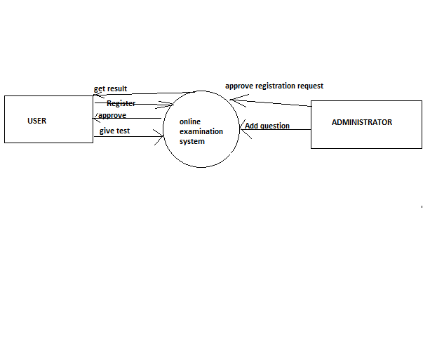

3.1.1 Level 1 diagram

The context-level DFD is then exploded to produce a Level 1 DFD which models the details of the system. The Level 1 DFD shows how the system is divided into sub-systems (processes), and how each processes deals with one or more of the data ﬂows to or from an external entity, and how the processes together provide all of the functionality of the system. The level 1 DFD also identiﬁes the internal data stores which must be there for the system to do its job, and shows the data ﬂow between the various parts of the system.

In the below Level 1 DFD, the attendance system has been decomposed further
into 5 processes which are namely attendance entry, Course Entry, Safe Bunk Calculator, Database synchronizer and minimum attendance classifier. Each processes is accessed by the user are stored in the database and are used in the system.

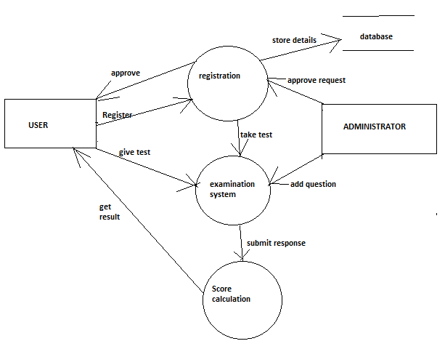

3.2 ER Diagram

The entity-relationship diagram is a data modelling technique that graphically represents an information systems entities and the relationships between those entities. An ER diagram is a conceptual and representational model of data which is used to represent the system framework infrastructure.
The ER diagram contains following elements:
- Entities
- Relationships
- Attributes
In designing the ER diagram, we identify and deﬁne all the entities, determine the interactions between the entities and determine the cardinality of the relationship.
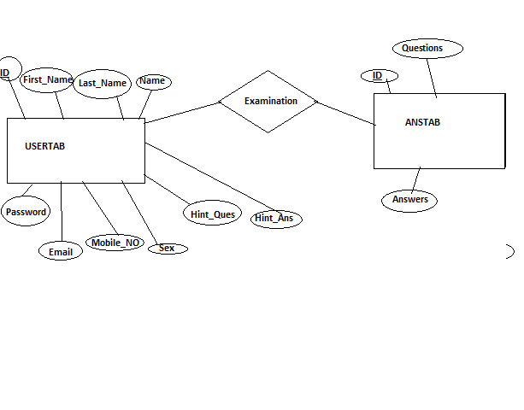

3.3 Sequence Diagram
Sequence diagram is an interaction diagram which shows how the processes interact with one another and in what order. It shows the object interactions arranged in time sequence. It represent the objects and classes involved in the scenario. It also shows the sequence of messages exchanged between those objects which is needed to perform diﬀerent functionality of the scenario. Sequence diagrams are associated with use case realizations of the Logical View of the system.

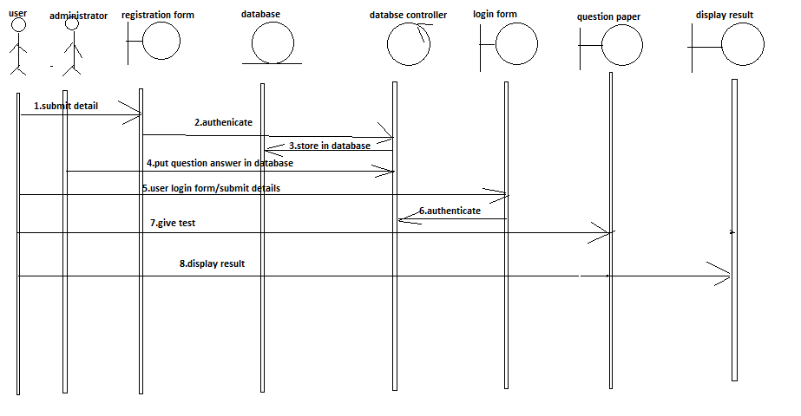

3.4 Class Diagram
Class diagram is a type of static structure diagram which describes the structure of a system by representing the classes of the system, their attributes, operations and the relationships among these classes.
